God called the unborn in Mary’s womb “the babe.”
Luke 1:41 (KJV) And it came to pass, that, when Elisabeth heard the salutation of Mary, the babe leaped in her womb; and Elisabeth was filled with the Holy Ghost:
Here is an excerpt from Alexandra DeSanctis’ article in National review about New York Governor Cuomo:
“On abortion, Cuomo casts aside his supposed Catholic convictions with greater ease than he takes them up.
For as long as man has had religion, religion has had hypocrites. The Catholic Church is no exception — it is, like all churches and all religions, full of sinners. In fact, that is its boast: No sin is too great, no Pharisee too far gone to be saved…. Andrew Cuomo, …has yet to find his road to Damascus. The governor of New York is proud to be a Catholic, but, like his father before him, only when it suits his political purposes. Last summer, when Pope Francis announced that the death penalty is never permissible, Cuomo rushed with all undue haste to claim the mantle of his familial creed.
“The death penalty is morally indefensible and has no place in the 21st century,” he opined on Twitter. “Today, in solidarity with @pontifex and in honor of my father, I will be advancing legislation to remove the death penalty from State law once and for all.” But Cuomo casts aside his supposed Catholic convictions with greater ease than he takes them up. This week, on the anniversary of the Supreme Court decision in Roe v. Wade, the governor signed into law the ghastly Reproductive Health Act (RHA). The legislation permits abortion up to 24 weeks of pregnancy — when abortion is never medically necessary and when children born prematurely are routinely able to survive outside the womb with careful tending — and it creates lenient exceptions essentially sanctioning elective abortion up to the moment of birth.”
Ms. Desanctis is correct.
Andrea Stewart-Cousins, the majority leader of the New York State Senate said, “Unfortunately for years, barriers to women’s rights were up…Today, we are tearing those barriers down.”
Cuomo said, “Today we are taking a giant step forward in the hard-fought battle to ensure a woman’s right to make her own decisions about her own personal health, including the ability to access an abortion…women in New York will have the fundamental right to control their own body.”
Not only did they vote for the law and had the law signed into effect by Cuomo, but they celebrated by lighting up the top one of the World Trade Center buildings, the Freedom Tower, in pink. Democrats celebrating the lawful murder of children. How anyone in their right mind could vote for a politician who would celebrate the murder of helpless unborn children is mind boggling.
Sarah Telle writing about this horrifying law says, “… Abortion isn’t empowering to women. It’s the opposite. It’s dehumanizing. It is destructive because abortion violates the most fundamental of all human rights—the right to life.”
God’s word is clear that the child is formed by God in the mother’s womb. God gives that baby life. He is the author of life. Therefore, to kill a baby in the mother’s womb is subvert the will of God for that child.
Job 31:15 (KJV) Did not he that made me in the womb make him? and did not one fashion us in the womb?
Psalm 139:13-16 (KJV) For thou hast possessed my reins: thou hast covered me in my mother's womb. I will praise thee; for I am fearfully and wonderfully made: marvellous are thy works; and that my soul knoweth right well. My substance was not hid from thee, when I was made in secret, and curiously wrought in the lowest parts of the earth. Thine eyes did see my substance, yet being unperfect; and in thy book all my members were written, which in continuance were fashioned, when as yet there was none of them.
Psalm 119:73 - Thy hands have made me and fashioned me: give me understanding, that I may learn thy commandments.
Romans 9:20 (KJV) Nay but, O man, who art thou that repliest against God? Shall the thing formed say to him that formed it, Why hast thou made me thus?
The above scriptures are a few of the scriptures that teach by precept and example that God is the author of life.
Abortion is the murder of an unborn baby who is a living child from conception. Abortionist’s call the unborn a “fetus.” The baby is not a fetus. Don't let the evolutionary liars of our day deceive you. By using the word "fetus" they are trying to trick you into believing that we humans are just animals. Human babies are not animals, they are human beings with all the possibilities that God placed in them when HE allowed the conception.
Here is Noah Webster's definition from his 1828 dictionary: "FE'TUS, n. plu. fetuses. [L. faetus.] The young of viviparous animals in the womb, and of oviparous animals in the egg, after it is perfectly formed; before which time it is called embryo. A young animal then is called a fetus from the time its parts are distinctly formed, till its birth..."
Nothing speaks louder about the degradation and depravity of man than his willingness to murder the most helpless-a baby in the womb. Anyone who is for this latest abomination from New York is against God. Pray for these sinners to get saved.
If you have never been saved, trust the Lord Jesus Christ today before it is too late for your soul.

Romans 10:8-11 KJV
But what saith it? The word is nigh thee, even in thy mouth, and in thy heart: that is, the word of faith, which we preach; [9] That if thou shalt confess with thy mouth the Lord Jesus, and shalt believe in thine heart that God hath raised him from the dead, thou shalt be saved. [10] For with the heart man believeth unto righteousness; and with the mouth confession is made unto salvation. [11] For the scripture saith, Whosoever believeth on him shall not be ashamed.

From your friends at:
“Old Paths” Baptist Ministries
1482 N. Ramah Dr., Pueblo West, CO 81007
www.opbm.org
Dr. Robert E. Bliss, Director
A ministry out of:
Rocky Mountain Baptist Church
2901 O’Neal Ave., Pueblo, CO 81005
Pastor Gordon Rogers
www.rockymountainbaptist.com

WHAT DOES GOD
HAVE TO SAY ABOUT
NEW YORK’S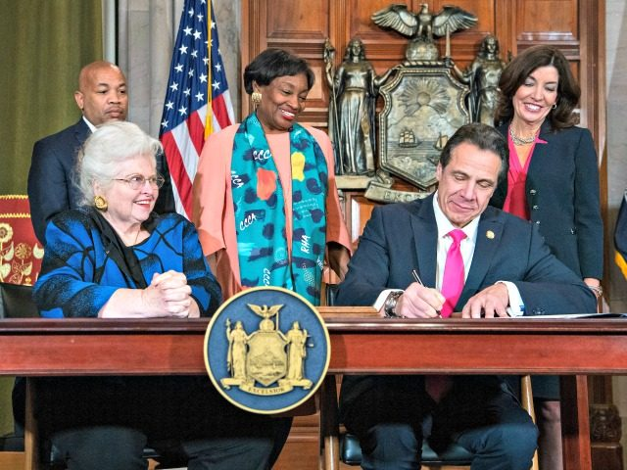 ABORTION LAW?

